From polygons to polyhedra and beyond
St Paul’s Catholic School Geometry Workshop I
Welcome to the first geometry workshop at St Paul’s. Today we’ll be looking at how polygons can be used to construct 3D shapes – polyhedra. But exactly which polygons will fit together to make a polyhedron? How many different ways of doing this are there? In general these questions are very hard to answer, but today we’re going to look at some of the maths behind the problem, and see how asking questions like these leads to the discovery of a whole new class of 3D shapes.

From polygons to polyhedra
Follow the recipes to try to construct your own polyhedra.
Which recipes give polyhedra? Which give flat tessellations? Which don’t work at all? Fill in the table.
Recipe | Polyhedra? | Tessellation? | Doesn’t work?

Can you tell in advance whether or not a recipe will work? If not, how soon can you tell?

These are the kind of questions mathematicians ask. How can we classify polyhedra? How many there are? Have we even found them all? These questions are difficult, but we’ll try to solve some special cases.

Euler’s formula
One way to study polyhedra is to count the number of vertices (corners), edges and faces they have.
Choose some polyhedra and fill in the table
Polyhedra | Vertices (V) | Edges (E) | Faces (F)

Can you see how V, E and F are linked?

Polyhedra can be viewed as special tessellations of a sphere. Any tessellation of a sphere will satisfy Euler’s formula!

The Platonic solids
Earlier we found some polyhedra in which every face was the same shape, and the same number of faces meet at each vertex. These special polyhedra are called Platonic solids.
How many are there? Did we find them all?

Beyond polyhedral

We’ve solved the problem for the Platonic solids. What next? We will look at generalising the Platonic solids to other surfaces. What do we mean by this?
Draw the surfaces of genus 0, 1 and 2.

What properties do we want a generalised Platonic solid to have?

A {p,q}-pattern is a tessellation where p faces meet at every vertex, and each face has q edges.
How can we adapt Euler’s formula to work for a surface of genus g?

How many {p,q}-patterns are possible?
The question now is how many of these possibilities actually exist?

Extension activity

Can you make this torus into a {4,4}-pattern?

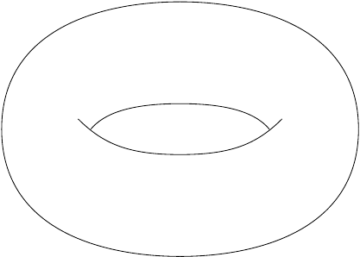

Can you make this double torus into a {6,4}-pattern?
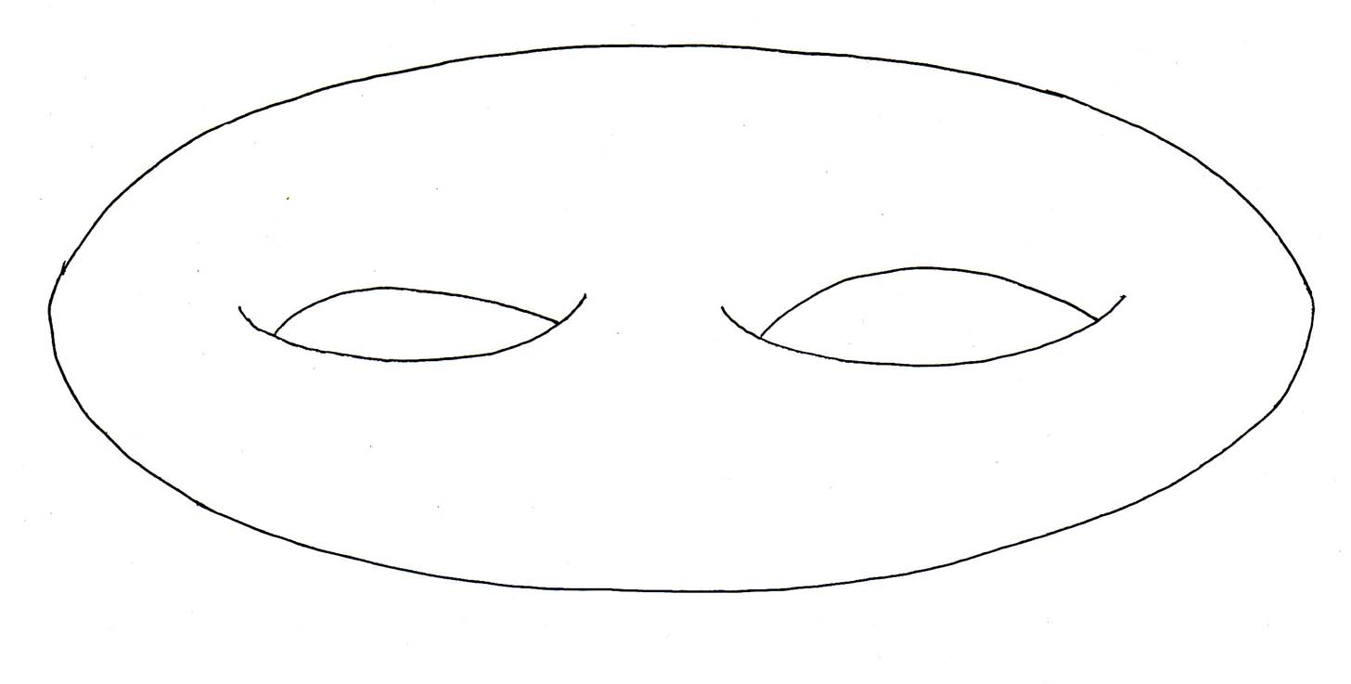

Links to more resources

- The Wikipedia page on polyhedra gives you a detailed description of all regular polyhedra and, in particular, the Platonic and Archimedean solids:
http://en.wikipedia.org/wiki/Polyhedron

David Martí-Pete
email: David.MartiPete@open.ac.uk
website: users.mct.open.ac.uk/dmp387
twitter: @davidmartipete
Mairi Walker
email: Mairi.Walker@open.ac.uk
website: www.mairiwalker.co.uk
twitter: @mairi_walker

