Fractals everywhere
St Paul’s Catholic School Geometry Workshop II
Welcome to the second geometry workshop at St Paul’s. Today we’ll be looking at the maths of fractals, which are mathematical objects with very surprising properties! We start off with a simple question: How long is the coastline of Great Britain? This turns out to be difficult to answer because coastlines are examples of fractals. In this workshop we’ll look at the difficulties in measuring fractals and see how this related to their dimension. Then we can apply what we’ve learnt to study the length of the coastline of Great Britain.

The coastline paradox and fractals

The coastline paradox is the observation that the length of a coastline is ambiguous, or, in mathematical terms, not well-defined; the length of a coastline depends on the scale at which you measure it, and increases without limit as the scale increases. Why is this? It is because coastlines are examples of fractals.
What is a fractal?

These are examples of fractals
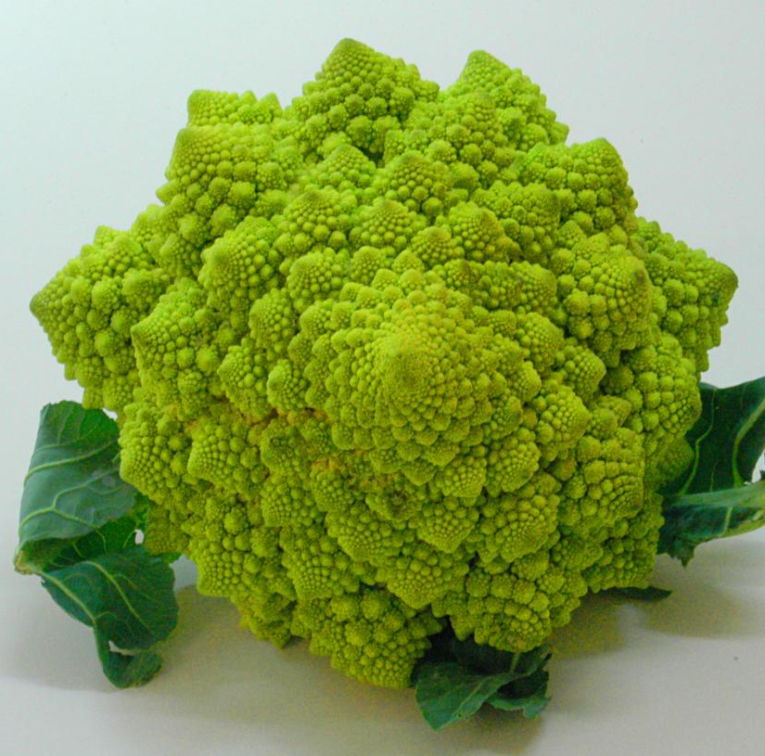 | 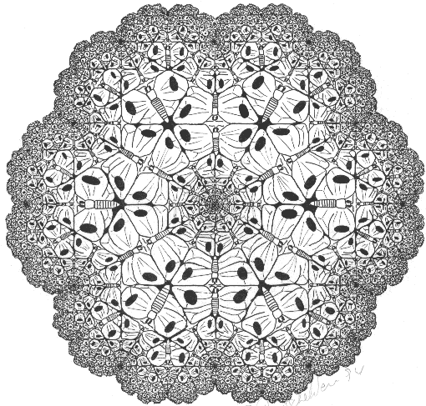 | 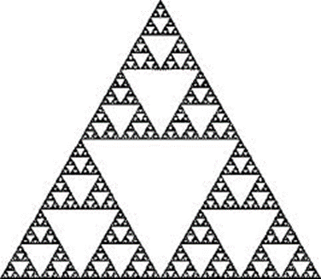 |  | 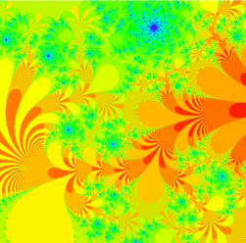

Geometric fractals

These are strictly self-similar: They are made up of smaller, exact copies of themselves. They can be created using a recursive rule: A geometric rule that you repeatedly apply to some initial shape.
The image below shows the first four steps in the construction of a fractal called the Sierpinski carpet. Assume that the length of the outer square in each image is 1 unit.
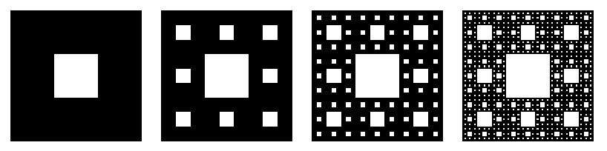
Fill in the following table.
Step | Number of squares | Area of squares | Area of image
1
2
3
n

What is the area of this fractal?

Fractal dimension

The strange measurements of fractals occur because they are neither one-dimensional nor two-dimensional, but something in between. The dimension of a fractal will usually not be a whole number, and we call this the fractal dimension of the number.

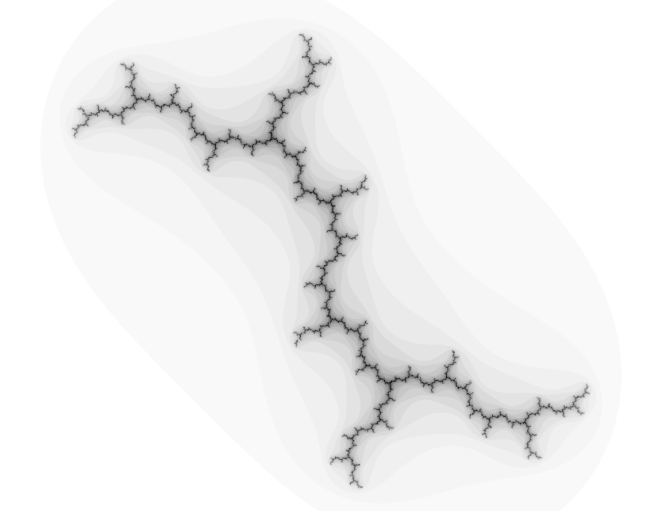 | 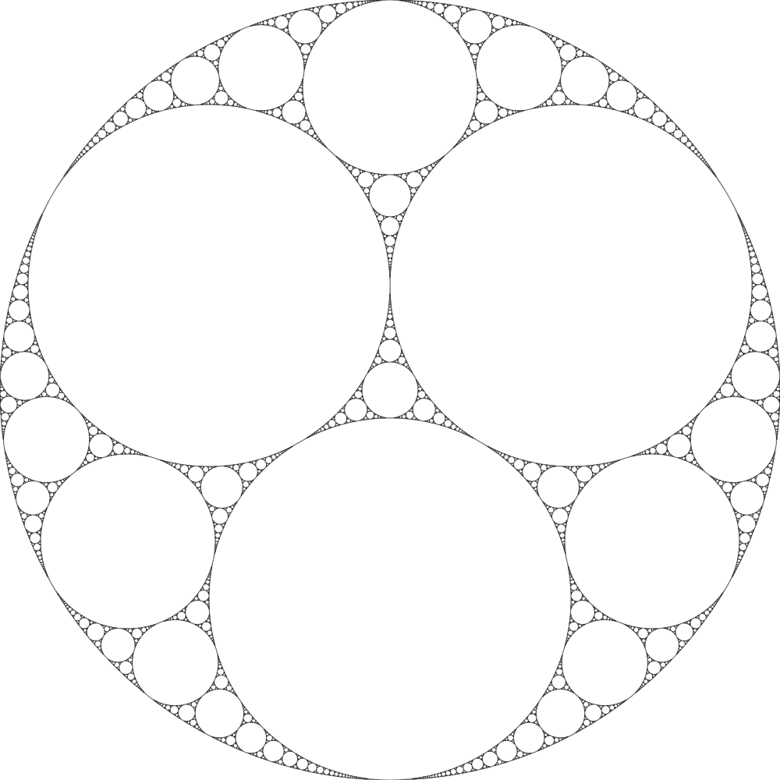 | 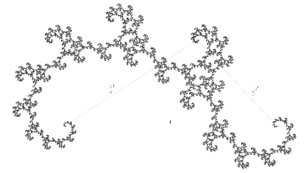
Dimension 1.2 | Dimension 1.3057 | Dimension 1.61803 | Dimension 1.8928
There are different ways of measuring the fractal dimension of a fractal. One is the similarity dimension. For a geometric fractal made up from N copies of itself, each of which is an r-sized copy of it, the similarity dimension d is
$$d=\frac{\log\left(N\right)}{\log\left(\frac{1}{r}\right)}.$$
The dimension can tell you a bit about the measurements of a fractal.
- If the dimension is less than 1 then the length and area will be zero.
- If the dimension is between 1 and 2 then length will be infinite but area will be zero.
- If the dimension is bigger than 2 then both length and area will be infinite.
This is the fractal you measured earlier.
What is the dimension?
N=

r=

d=

What does this say about the length and area of the fractal?
This fractal is called the von Koch curve.

What is the dimension?

What does this say about the length and area of the fractal?

Extension activity
Design your own self-similar fractal and calculate the dimension.

Do it yourself!
You can download the fractal zoomer Xaos from
http://matek.hu/xaos
and explore the fractal sets that we have introduced in this workshop. And if you like programming, you can generate these pictures with what you have learnt today!

David Martí-Pete
email: David.MartiPete@open.ac.uk
website: users.mct.open.ac.uk/dmp387
twitter: @davidmartipete
Mairi Walker
email: Mairi.Walker@open.ac.uk
website: www.mairiwalker.co.uk
twitter: @mairi_walker

